**For part2, I iterated over every instruction in the fib function:**



**Then, I searched the instructions for call and return instructions:**





**Then, I created a call to fiblogger:**



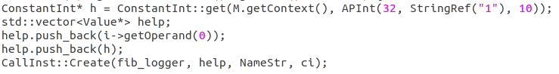

**The result of make diff is this:**

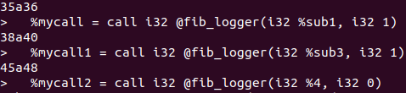

**fib.ll:**

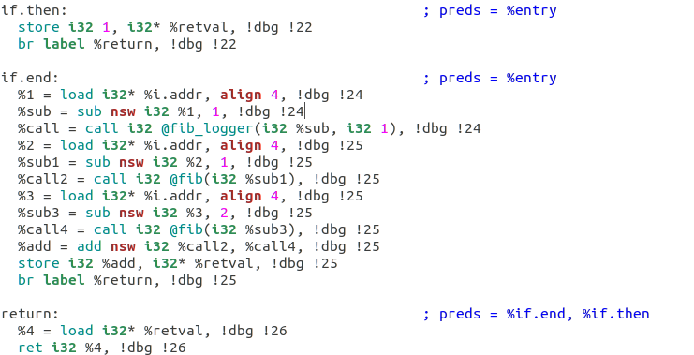

**fib_opt.ll:**

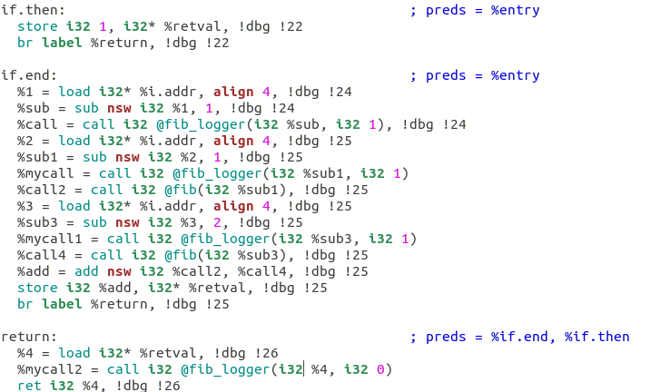

**Result of ./fibhacked (my exe that i created using the fib_opt.ll file):**

